Team name: TingTartT

Chosen theme: Life on Earth

Organisation name: Kvadraturen Videregående skole

Country: Norway

1. Introduction

**_____________________________________________**

We decided to investigate to what extent volcanic activity like volcanic ash and testing of nuclear weapons affect vegetation on Earth, by comparing areas that are or have been affected, to areas that haven’t. We also wanted to use the data we gathered from the ISS to compare it with old NDVI data from NASA's archive, but we decided to use another method because the data we got was not affected by circumstances we decided to measure at the same time NASA was gathering NDVI data. We think that this experiment is interesting because all of us like explosions, and we wanted to investigate how they affect vegetation on Earth. We expect to find out that volcanoes help vegetation to grow and that nuclear activity doesn’t affect vegetation amount nearby.

Here is our ISS flight path. Unfortunately, a big part of the earth was covered by clouds at the time of our investigation, so we got little data, but we think we used it the best way we could.

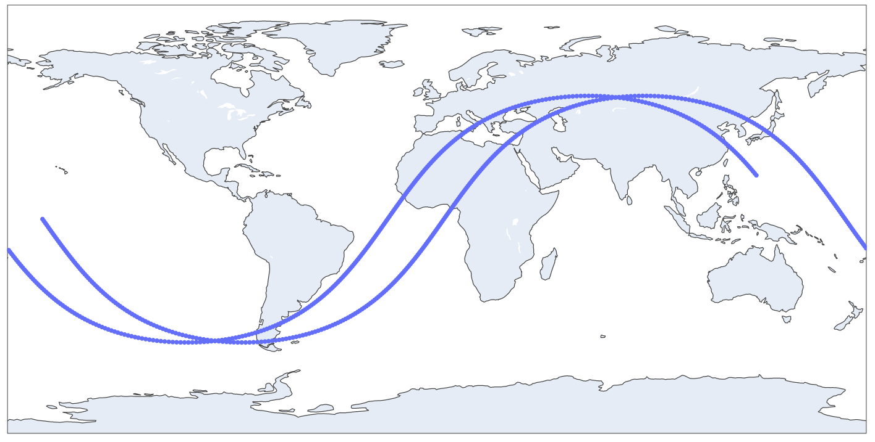



2. Method

**_____________________________________________**

We decided to measure how volcanic activity and nuclear explosions affect the vegetation amount on earth. We used a camera with an NDVI filter to take photos and save them in JPEG format along with data to find the location and time the photos were taken, we kept these types of data in a CSV file.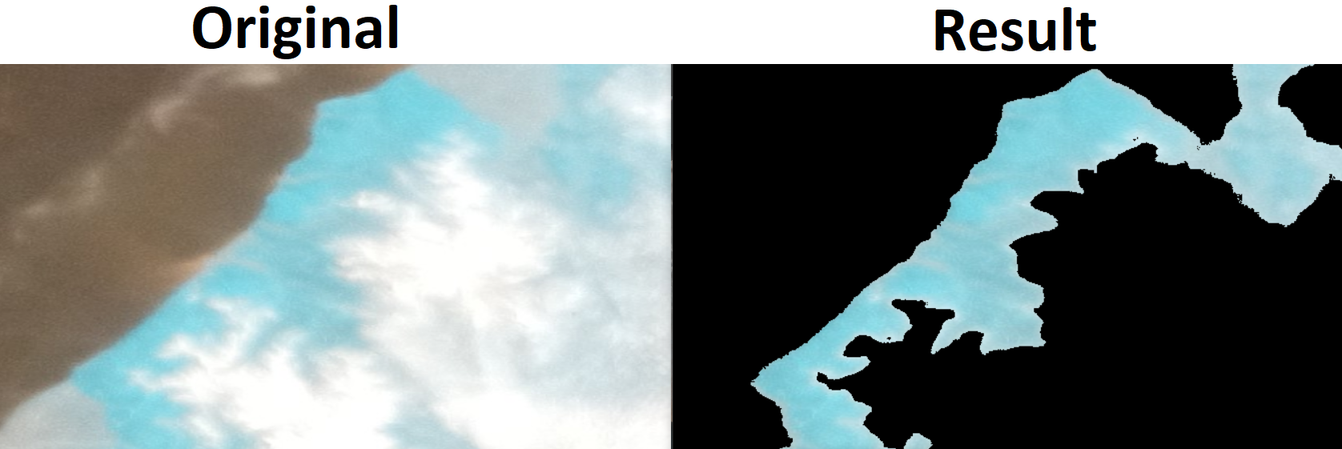

We wrote a script that calculates average vegetation in the photos we gathered from the ISS and NDVI data from NASA's archives. The script requires one or two photos, one from ISS and one from an HDF file from the MOBIUS sensor that we found on [search.earthdata.nasa.gov](https://search.earthdata.nasa.gov/). The script can cut off every unnecessary detail leaving the vegetation as you can see in the Image 2. As an output, we get the average brightness of the images. It represents the average amount of vegetation, we are not calculating the NDVI value because we are only interested in comparing the data with photos in NASA's archive and areas we got photos of. With average brightness, we can calculate the average density of vegetation that we use for compressing.

Repository with all scripts - <https://github.com/Smulee/AstroPi2022-TingTarT>

The process of processing images: 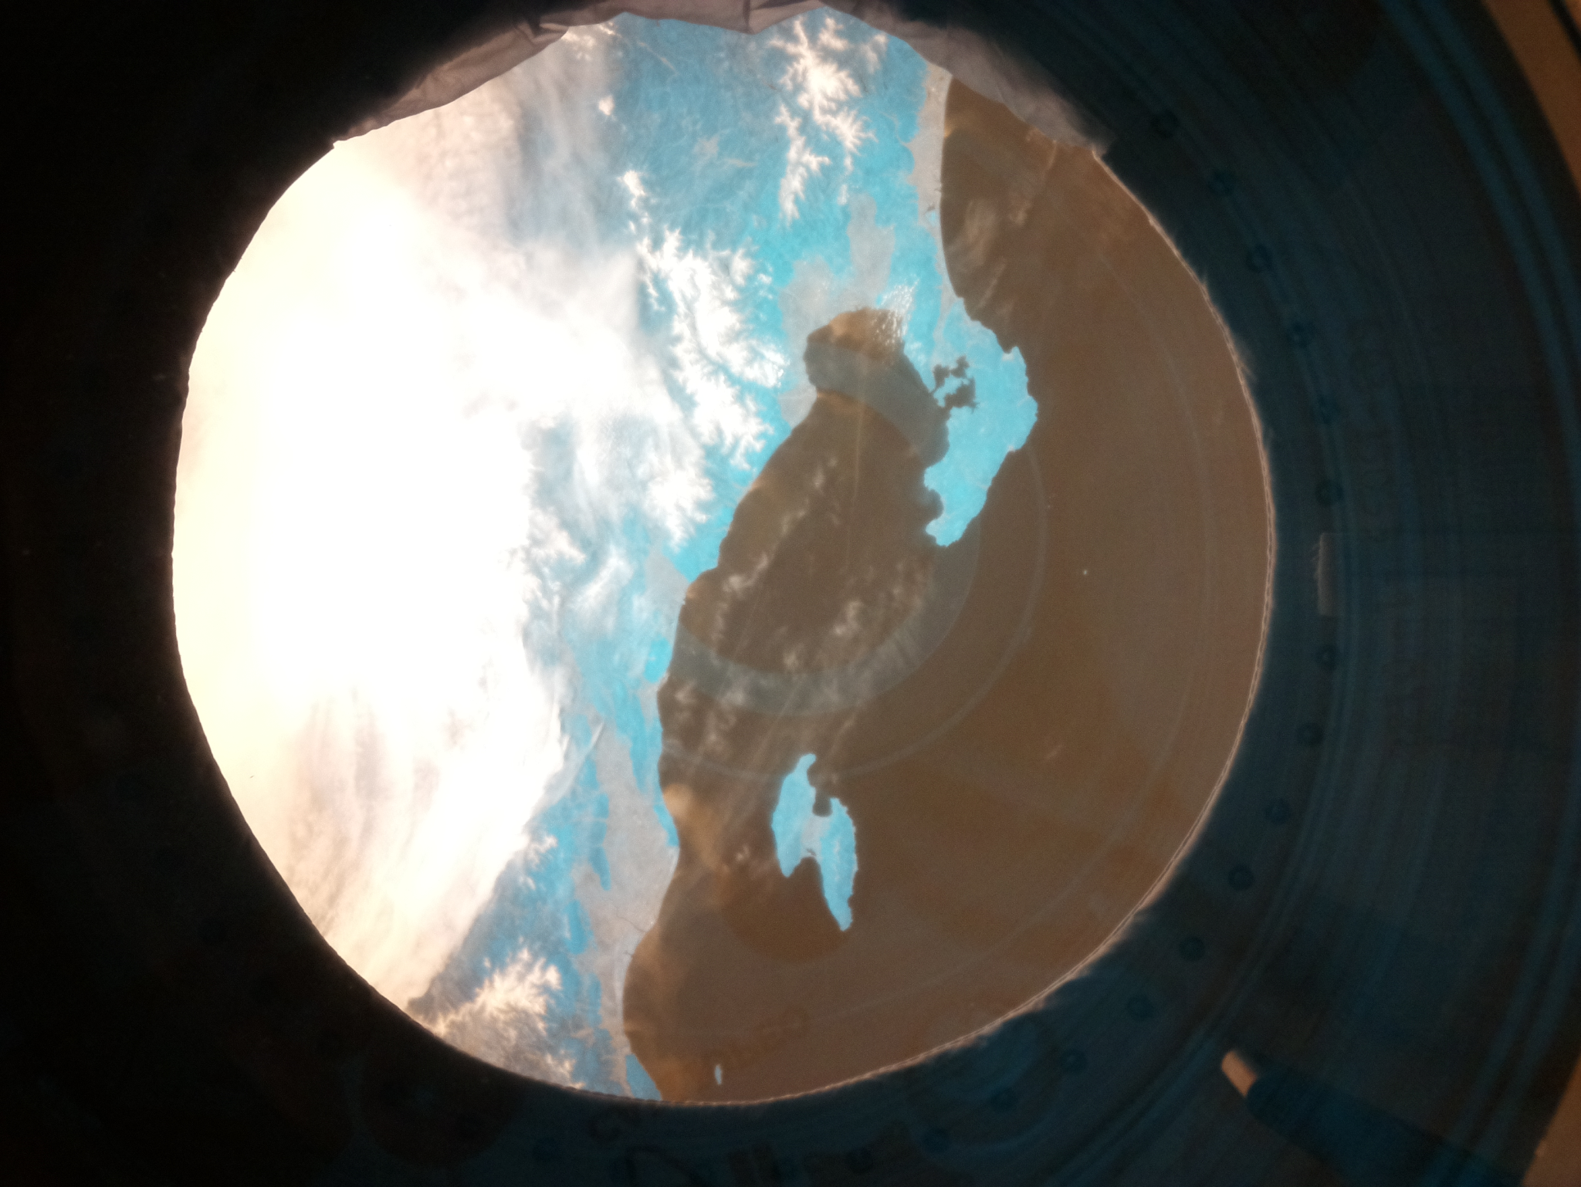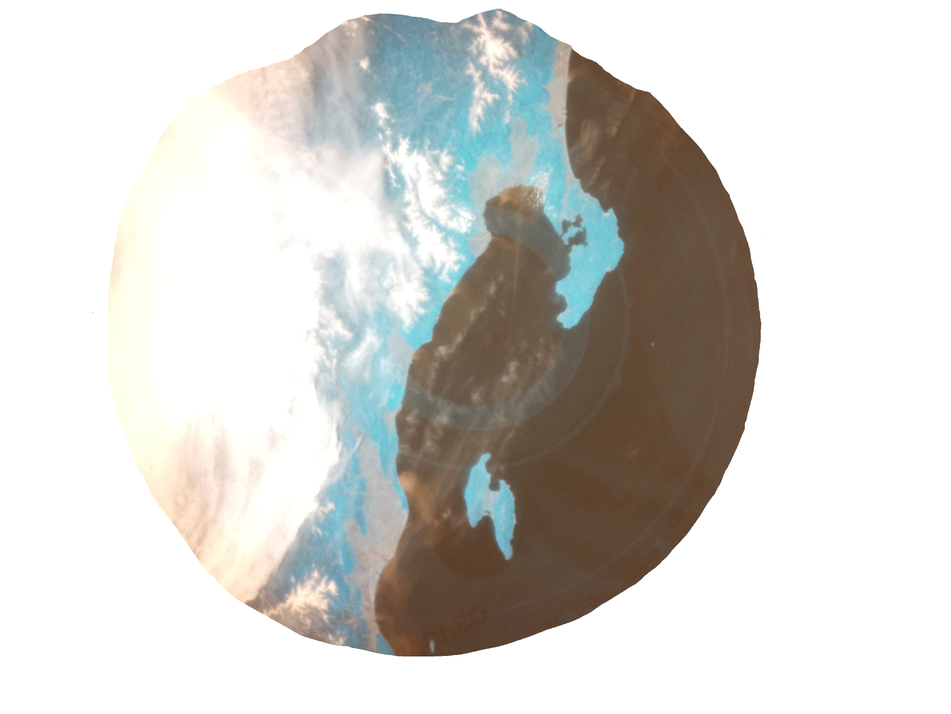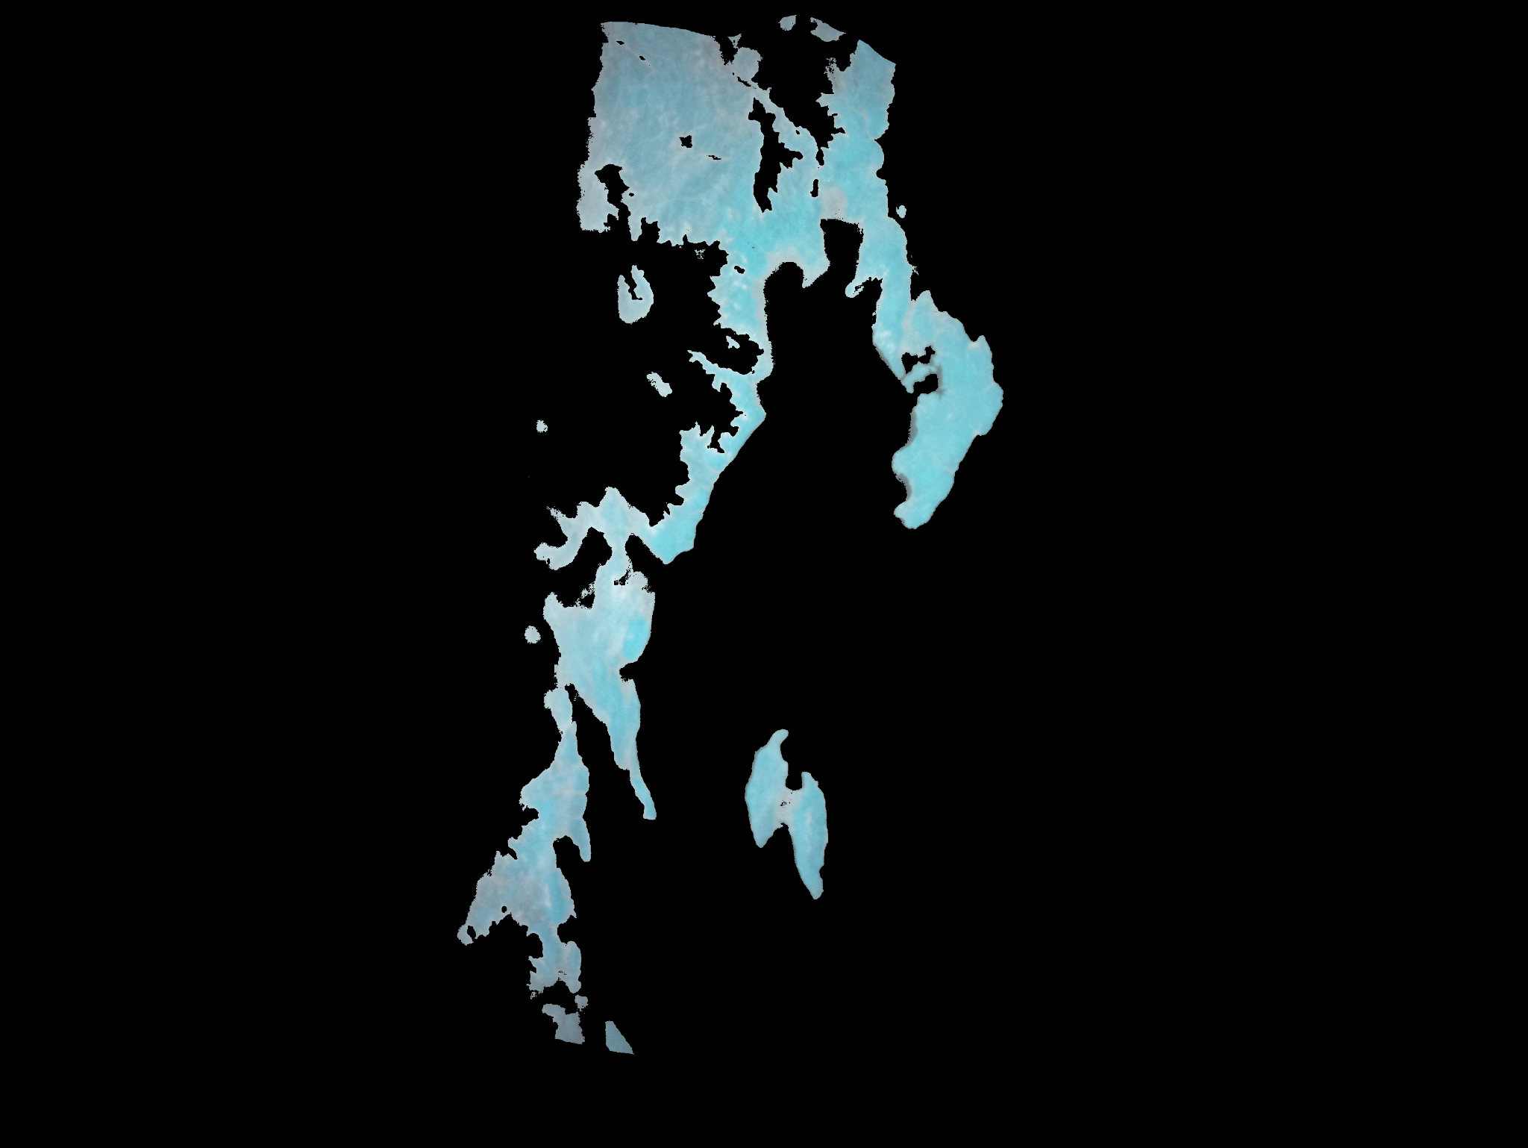





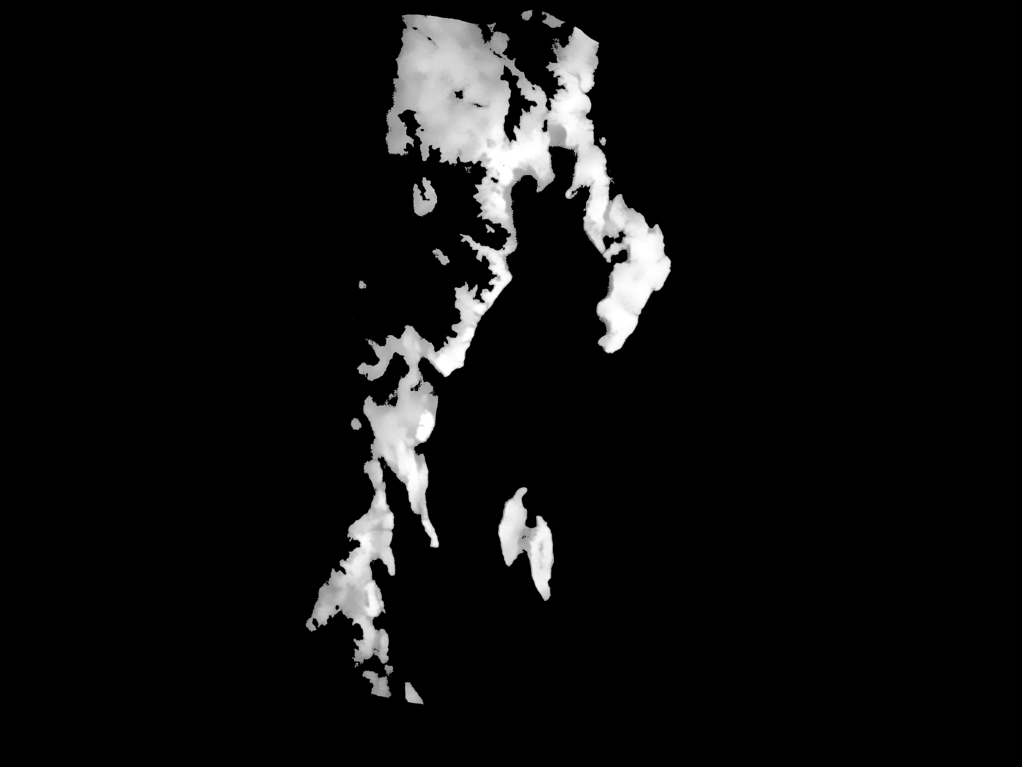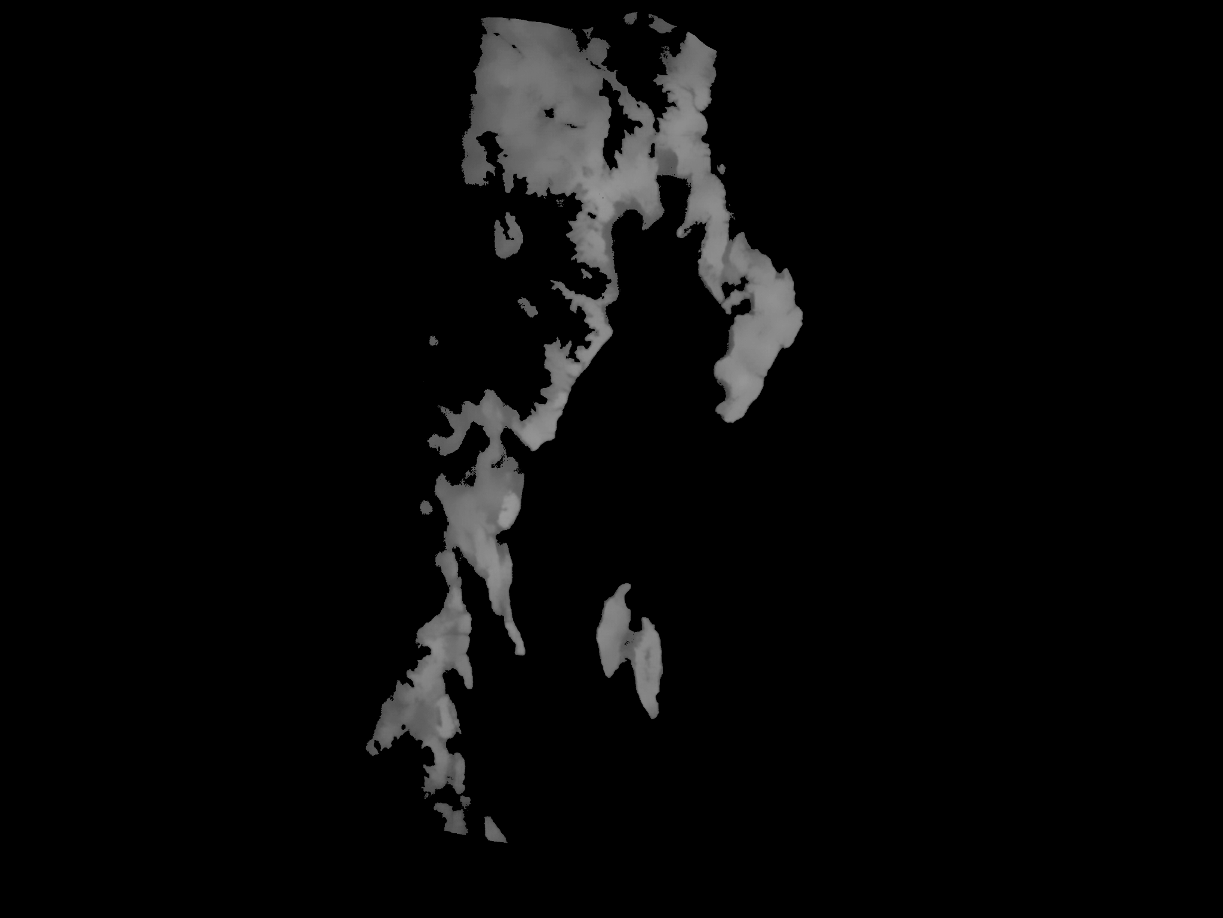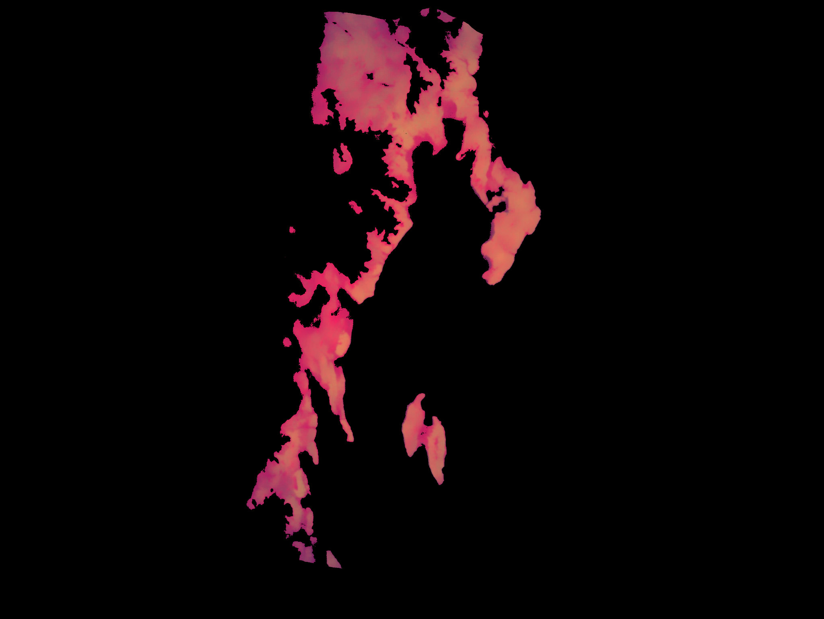



3. Experiment results

**_____________________________________________**

We flew over two areas that we found useful:

* The Semipalatinsk nuclear test site in Kazakhstan which is the biggest Soviet nuclear polygon.
* The west part of Japan. Japan is full of volcanoes, and the part that we were lucky to get. Has active volcanoes nearby.

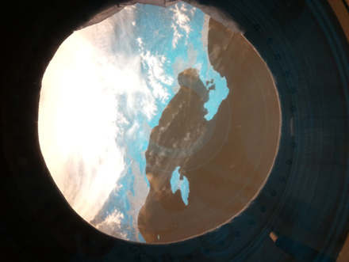The volcano that we used for analyzing the effect volcanoes have on vegetation is called Niigata-Yake-Yama. The last time it erupted was in 1974. NASA doesn't have NDVI data that goes so far back in time. So we could not analyze it the way we initially wanted. Instead, we compared vegetation near the volcano with vegetation in an area of Japan with no volcanoes, this region is the coast of Tottori. 

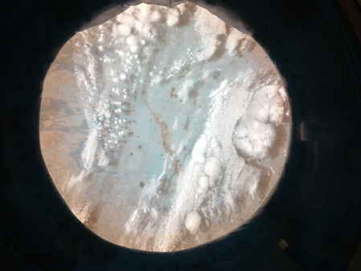We found no evidence for our hypothesis. The density of vegetation on the coast of Tottori is around 80% and the vegetation near the volcano Niigata-Yake-Yama is 79.2%, practically the same. We think it may be unaffected because of how long it’s been since the last eruption, or that the soil in Japan is so good that it supports a big density of vegetation in all areas, so even if the soil would have more nutrients it wouldn't affect the density of vegetation. 

This test site was in use from 1945 to 1991, NASA's NDVI data go back to 2000 so we could not analyze the initial effect of radiation on the vegetation nearby. So instead, we compared the area around the site with other parts of Kazakhstan that were not affected by radiation. The exact place of testing was partly covered by clouds and shadows of clouds during our pictures. We got data just from a small portion of this area.

Although we found no evidence that radiation from nuclear explosions affects the amount of vegetation on earth, as expected.

4. Learnings

**_____________________________________________**

Our team is made of students who like data science, physics, and electronics, so it was fun for us to participate. We had many meetings to maintain good communication in the team, we made a discord server for sharing data and talking. In addition, the organization of work wasn't demanding for each member, we spoke about what must be done, and if anyone had time then he did as much as he could. We organized it this way because we had a lot of time to get the work done. The biggest challenge was that we didn't know how to analyze photos, so we needed to develop a way of doing that by ourselves, luckily one of us has previous experience working with CV2, so we found a method to do this without learning everything from scratch. We learned how to use NASA's archives and take data from these, as well as work with the .HDF format that is used for storing scientific data. Next time we should be together in the same room more while working on planning, coding, and analyzing. During this project we did not do that and that caused some communication problems.

5. Conclusion

**_____________________________________________**

Based on our findings, we cannot prove the first part of our initial hypothesis that volcanoes would help the growth vegetation. But we can conclude that Vegetation in Japan is not affected by volcanic eruptions older than 50 years. Though this may not be the case in other locations, as we only analyzed a single volcanic site. On the other hand, the data from the nuclear site concur with our hypothesis that radiation would not affect vegetation amount in the long term because we found no evidence that radiation from nuclear explosions influences the amount of vegetation on earth in any direction. In addition, we learned a lot about analyzing and working with photos in python and gathering data from NASA's archive as well as using them. This way of working on a project is different from what school has made us used to, so it was a good experience to learn other ways of working on projects.

We would love to thank ESA and the Raspberry Pi foundation for making AstroPI happen and that we could participate, it was a lot of fun, and some of us will definitely participate again.